ELEG 312 - Example Problems Chapter 10-1

**Example 10.1**

We wish to select appropriate values for the coupling capacitors *CC*1 and *CC*2 and the bypass capacitor *CS* for a CS amplifier for which *RG* = 4.7 MΩ, *RD* = *RL* = 15 kΩ, *Rsig* = 100 kΩ, *RS* = 10 kΩ, and *gm* = 1 mA/V. It is required to have *fL* at 100 Hz and that the nearest break frequency be at least a decade lower.

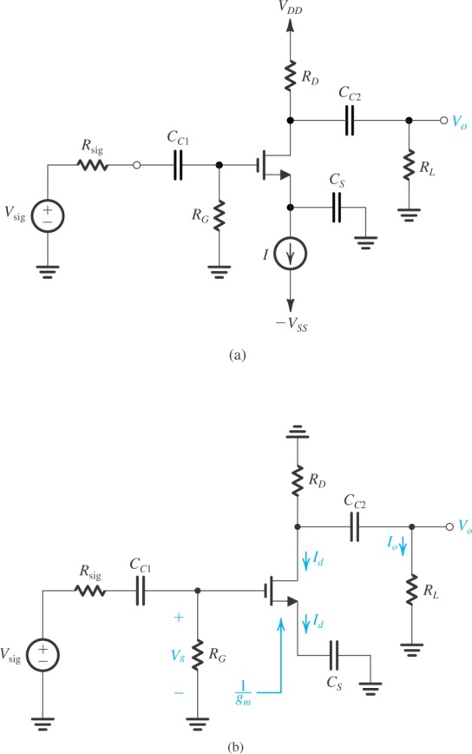

**Example 10.2**

We wish to select appropriate values for *CC*1, *CC*2, and *CE* for the common-emitter amplifier, which has *RB* = 100 k, *RC* = 8 k, *RL* = 5 k, *R*sig = 5 k, *RE* = 5 k, *β* = 100, *gm* = 40 mA/V, and *rπ* =2.5 k. It is required to have *fL* = 100 Hz.

**Problem 10.22**

A particular small-geometry BJT has *fT* of 10 GHz and *Cμ* = 0.1 pF when operated at *IC* = 1.0 mA. What is *Cπ* in this situation? Also, find *gm*. For *β* = 120, find *rπ* and *fβ*.